ROBOT FRAME WORK

Issues | Topics | Problems | Overcomes | References
Robot Framework for Test Automation | -Introduction  -How it works?  -Example |  |  | https://robotframework.org/
Let’s See an Example | -HTML pages design for testing  -Environment Setup  -Test Case Design |  |  | https://github.com/robotframework/WebDemo
Environment Setup | -Robot Framework Installation  -Selenium Library installations  -Web-driver installation | -Web-driver installation error | See : “Solution to Web-driver installation error” | Robot:  https://github.com/robotframework/robotframework/blob/master/INSTALL.rst  Selenium Library:  https://github.com/robotframework/SeleniumLibrary
Test Case Design | -Keyword Definition(resource)  -General Test Case Design  -Gherkin_Style Test Case Design |  |  | https://github.com/robotframework/WebDemo

Introduction
Robot Framework is a generic open source automation framework. It can be used for test automation and robotic process automation (RPA).
- Robot Framework is open and extensible and can be integrated virtually with any other tool to create powerful and flexible automation solutions. Being open source also means that Robot Framework is free to use without licensing costs.
- Its capabilities can be extended by libraries implemented with Python or Java. Robot Framework is operating system and application independent. The core framework is implemented using Python and also runs on Jython (JVM) and IronPython (.NET).
- Robot Framework itself is a open source software release, and most of the libraries and tools in the ecosystem are also open source. The framework was initially developed at Nokia Networks and was open sourced in 2008.

How It Works?
- Robot Framework has a modular architecture that can be extended with bundled and self-made libraries.
- Data is defined in files using defined syntax.
- A file, containing tests or tasks, creates a suite, and placing these files into directories creates a nested structure of suites.
- When execution is started, the framework first parses the data.
- It then utilizes keywords provided by the libraries to interact with the target system.
- Libraries can communicate with the system either directly or using other tools as drivers.
- Test or task execution is started from the command line. As a result, you get a report and log in HTML format as well as an XML output.
- These provide an extensive look into what your system does.
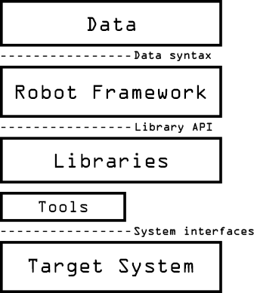

Let’s See an Example
- HTML pages

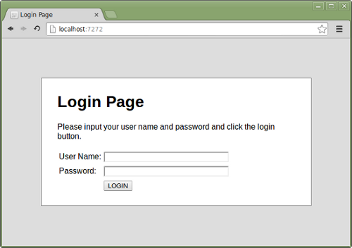

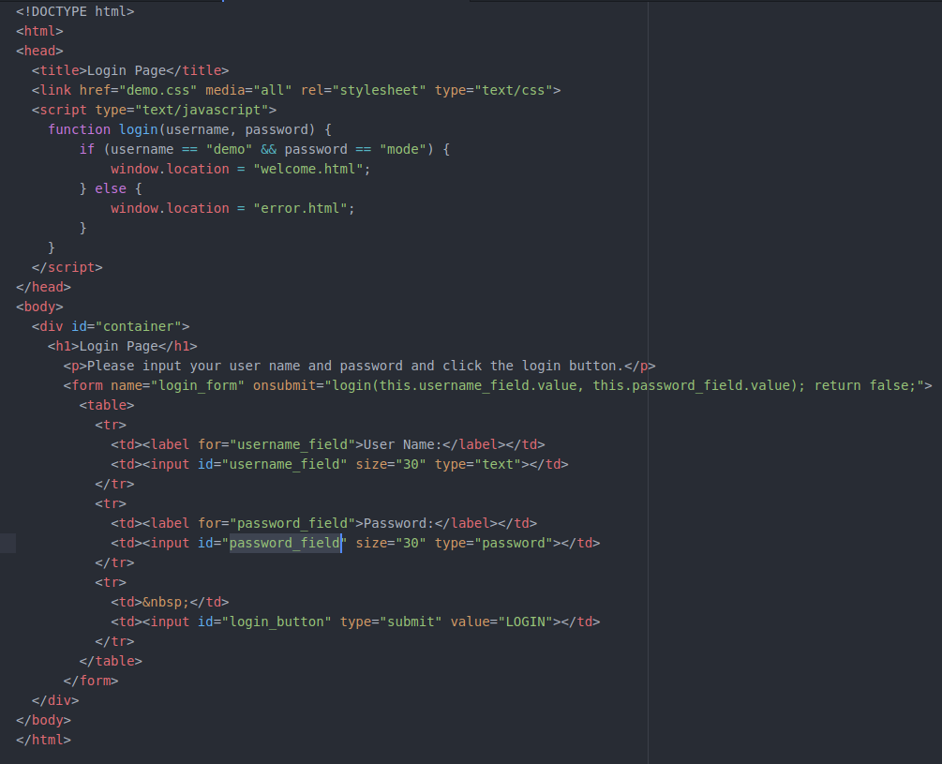

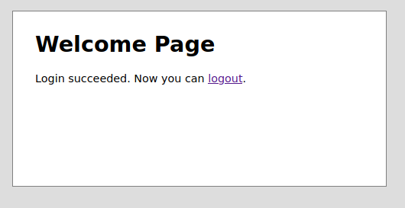
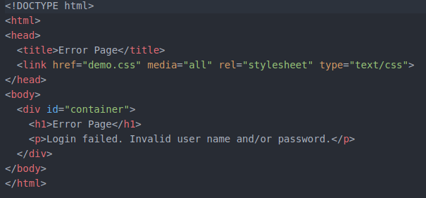
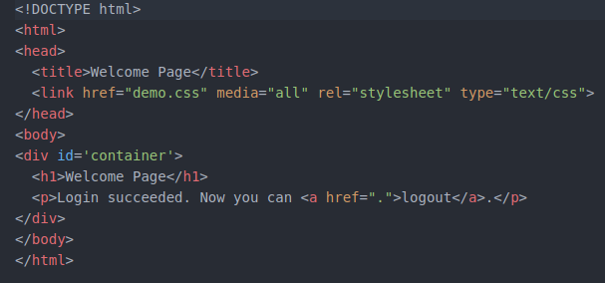
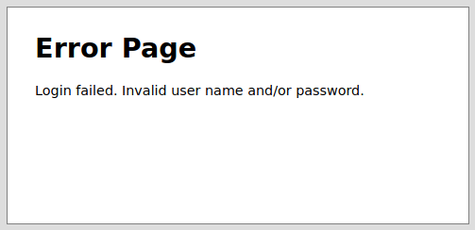

- Environment Setup [pip2/pip3]
- Robot Framework Installation command: sudo pip3 install robotframework

- Selenium Library Installation command: sudo pip3 install --upgrade robotframework-seleniumlibrary or sudo pip install --upgrade robotframework-selenium2library

- Web-driver Installation commands: pip3 install webdrivermanager
webdrivermanager firefox chrome –linkpath /usr/local/bin

pip3 install -r requirements.txt

If this command of web-driver installation fails, then try the bellow options and then run these options again.
Solution to Web-driver installation error:
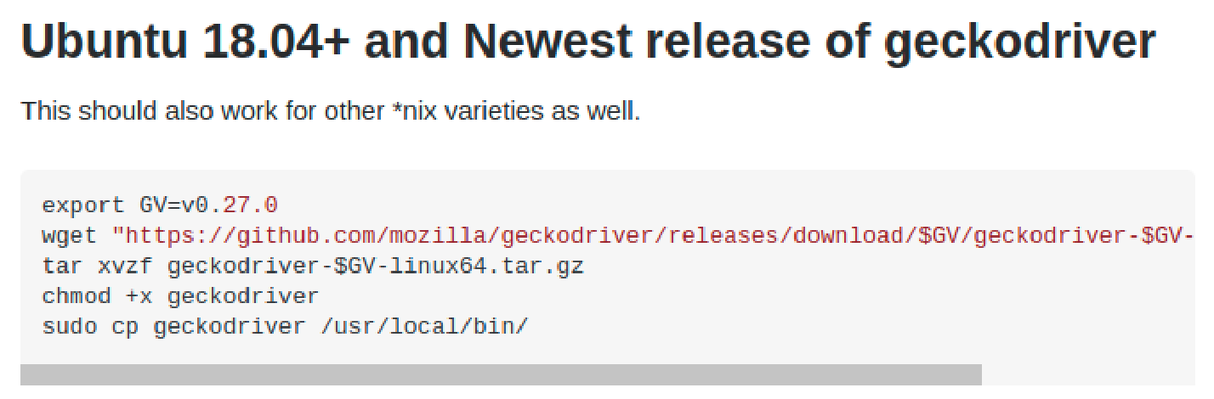

wget https://github.com/mozilla/geckodriver/releases/download/$GV/geckodriver-$GV-linux64.tar.gz

tar xvzf geckodriver-$GV-linux64.tar.gz

- Test Case Design
- Keyword Definition:

resource. robot
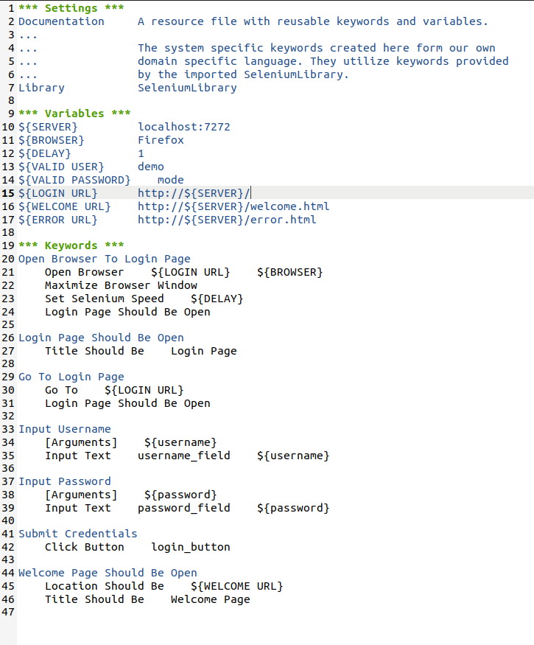

- Test Case Design

valid_login. robot
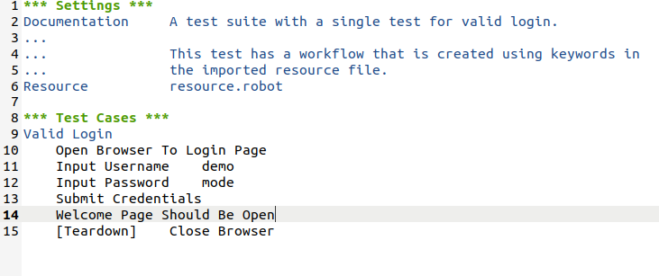

invalid_login. robot
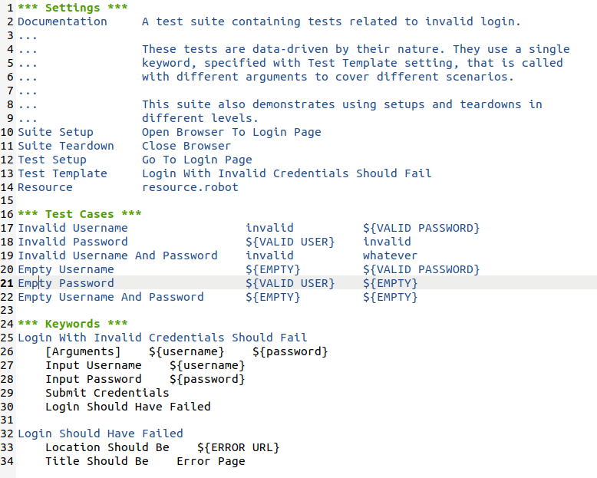
- Gherkin Style Test Case Design
gherkin_style. robot
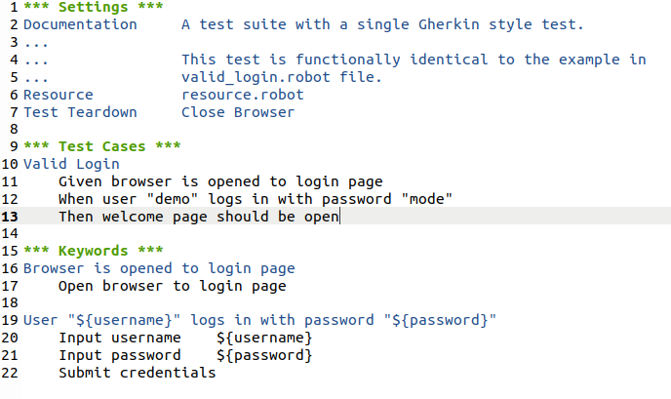

Test Command:
robot folder_name/ sub_folder_name

